EX NO:2(A) **EXCHANGE OF TWO VALUES**

DATE:7.12.22

**ALGORITHM:**

STEP1: read a,b values.

STEP2: assume a temporary variable.

STEP3: t=a,a=b,b=t.

STEP4: display a,b values.

STEP5: end.

**FLOWCHART:**

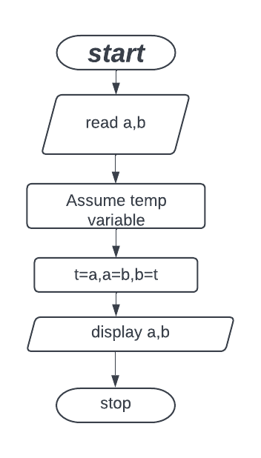

**CODE:**  **OUTPUT:**

|  |
| --- |
| Enter a value:10  Enter b value:40  The value of a is 40  The value of b is 10 |

a=int(input(“enter a value:”)) b=int(input(“enter b value:”)) t=a

a=b b=t

print(“the value of a is :”,a)

print(“the value of b is:”,b)

**METHOD 2:**

a=int(input(“enter a value:”))

b=int(input(“enter b value:”))

print(“the value of a is :”,b)

print(“the value of b is:”,a)

**METHOD 3:**

a=int(input(“enter a value:”))

b=int(input(“enter b value:”))

x = x + y

y = x - y

x = x – y

print(“the value of a is :”,a)

print(“the value of b is:”,b)

EX NO:2(B) **CIRCULATING THE LIST OF VALUES**

DATE:7.12.22

**ALGORITHM:**

STEP1: Start

STEP2: Define a function circulate for a and n and i=1

STEP3: for i in to n+1

STEP 3.1:Slice the first element using a[1:] and slice rest of the element in a[:1]and store them in b=a[1:]+a [:1]

STEP 3.2: Print b.

STEP4: Get the values of list in variable a

STEP 5: Get the number of rotation in variable n

STEP6: Print the circulated list

STEP7: Stop

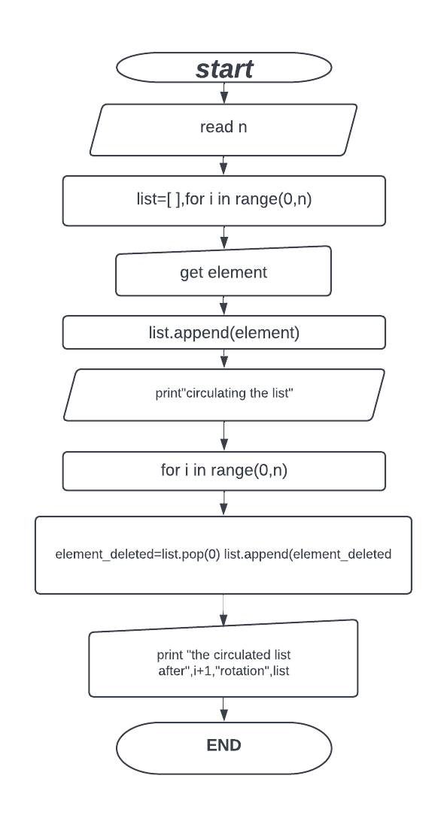

**FLOWCHART:**

**CODE: OUTPUT:**

Enter a value in the list:6

Enter a value:45

Enter a value:34

Enter a value:23

Enter a value:56

Enter a value:67

Enter a value:89

Circulating the list

After1 rotation[34,23,56,67,89,45]

After2rotation[23,56,67,89,45,34]

After3rotation[56,67,89,45,34,23]

Ater4rotation[67,89,45,34,23,56]

After5rotation[89,45,34,23,56,67]

After6rotation[45,34,23,56,67,89]

N=int(input(“enter a value in the list :”))

List=[ ]

for i in range(0,n):

element=int(input(“enter a value:”))

list.append(element)

print(“circulating the list”)

for i in range(0,n)

element_deleted=list.pop(0)

list.append(element_deleted)

print(“the circulated list” ,i+1,“rotation”,list)

EX NO:2(C) **DISTANCE BETWEEN TWO POINTS**

DATE:7.12.22

**ALGORITHM:**

STEP 1: Start

STEP 2: Get the Values of x1,x2,y1,y2

STEP 3: Using the formulae,D=(x1-x2)^2+(y1-y2)^2,calculate D value.

STEP 4: Display D value.

STEP 5: Stop.

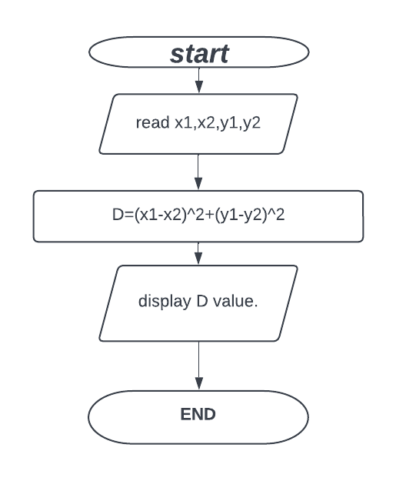

**FLOWCHART:**

**CODING: OUTPUT:**

Enter x1 value:20

Enter x2 value:40

Enter y1 value:12

Enter y2 value:23

The distance between two points is :25

X1=int(input(“enter x1 value:”))

X2=int(input(“enter x2 value:”))

Y1=int(input(“enter y1 value:”))

Y2=int(input(“enter y2 value:”))

D=(x1-x2)^2+(y1-y2)^2.

Print(“the distance between two points is:”,D)

**PRACTICE PROBLEMS:**

**ARITHMETIC OPERATIONS**

**CODING: OUTPUT:**

Enter a value:10

Enter b value:100

Add=110,sub=-90,mul=1000,div=1000,fl_div=0

a=int(input(“enter a value:”))

b=int(input(“enter b value:”))

c=alb

d=a/b

e=a//b

f=a*b

g=a-b

print(“add”=c, “sub”=g, “mul”=f, “div”=d, “fl_div”=e)

**WEIGHT OF AN APPLE**

**CODING: OUTPUT:**

The cost of applesper kg:20

Total_weight:3

The total_cost of apple is:60.

Cost=int(input(“the cost of apples per kg:”))

Total_weight=int(input(“ Total_weight :”))

Total_cost=cost*Total_weight.

Print(“ The Total_cost of the apples is:”,Total_cost)

**FAHRENHEIT TO CELSIUS.**

**CODING: OUTPUT:**

Enter Fahrenheit value:50

The celsius value is :10

F=int(input(“Enter Fahrenheit value:”))

C=(F-32)*5/9.

Print(“the celsius value is :”,C)

**CALCULATING THE COST OF BOOKS WITH DISCOUNT**

**CODING: OUTPUT:**

enter B1 value:500

enter B2 value:450

enter B3 value:400

enter B4 value:200

enter B5 value:100

the final bill is :82.5.

B1=int (input(“enter B1 value:”))

B2=int (input(“enter B2 value:”))

B3=int (input(“enter B3 value:”))

B4=int (input(“enter B4 value:”))

B5=int (input(“enter B5 value:”))

Total=B1+B2+B3+B4+B5.

Discounted_bill=B1*5/100+B2*5/100+B3*B3/100+B4*5/100+B5*5/100.

Print(“the final bill is : ”, Discounted_bill)

**PRIME NUMBER OR NOT.**

**CODING: OUTPUT:**

Enter n:23

The given is prime number.

N=int(input(“enter n:”))

i=2

for i in range(2,n):

if n%2==0:

print(“the given number is not a prime number”)

else:

print(“the given number is a prime number”)

**LEAP YEAR OR NOT**

**CODING: OUTPUT:**

Enter year:2024

Not a leap year.

year=int(input(“enter year:”))

if(year %4==0):

if(year%100==0):

if(year%400==0):

print(“leap year”)

else:

print(“not a leap year”)

**SIMPLE INTEREST CALCULATION.**

**CODING: OUTPUT:**

Enter P value:40000

Enter N value:23

Enter R value: 20

The simple interest is :184000.0

P=int(input(“enter p value:”)

N=int(input (“enter n value:”)

R=int(input(“enter r value:”)

S_I=P*N*R/100.

Print(“ the simple interest value is : ”,S_I)